Creative Mass Designs

A Creative Mass Design (not abstract)
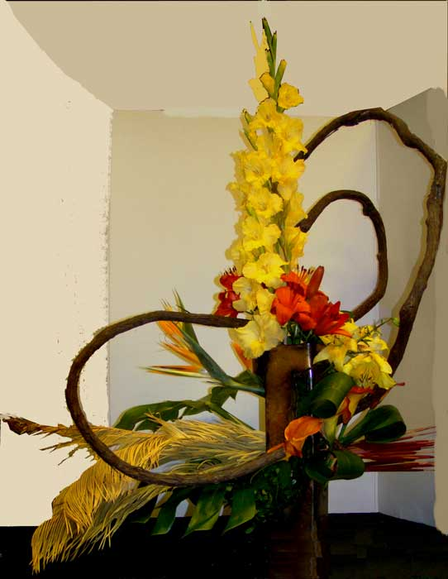
http://www.oagc.org/school%203%20p2.htm
Juanita Wilkins – Designer
A large grouping of quantities and types of plant materials in a creative container to form a large closed silhouette."
Open spaces within the design will create a different mass effect and still leave the silhouette closed. Designs may be of any form, but avoid using the basic traditional forms of circles, ovals and triangles. Elongated, exaggerated forms are best. Stylized forms are created by combining forms, over-lapping forms, and by using parts of forms in different ways. There may be more than one focal area and more than one point of emergence.

Line-Mass
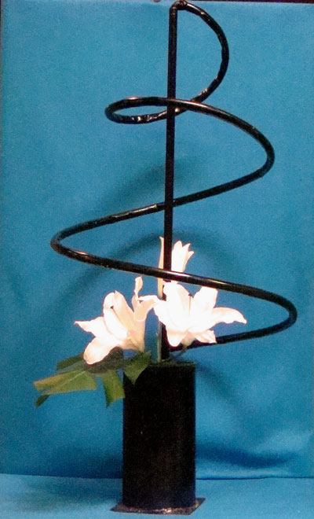
Creative Circular
Elenor Long Designer
http://www.oagc.org/e%20&%20J%20schools/2013%20schools/circular-line-mass.jpg

Creative Line Mass (with abstraction)
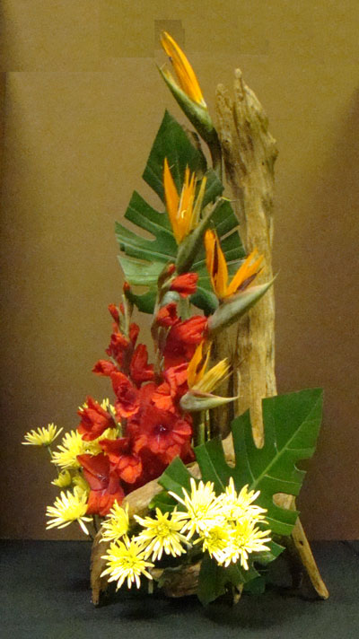
http://www.oagc.org/e%20&%20J%20schools/2013%20schools/creative-line-mass.jpg
Vertical Manner
Myrna Cordray, Designer

Creative Mass
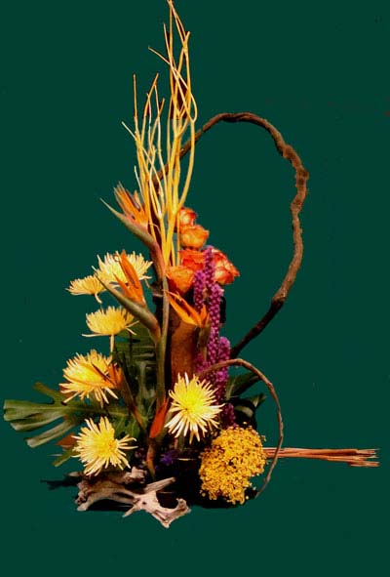
http://www.oagc.org/e%20&%20J%20schools/2013%20schools/creative-mass.jpg
Juanita Wilkins, Designer

Creative Vertical Line
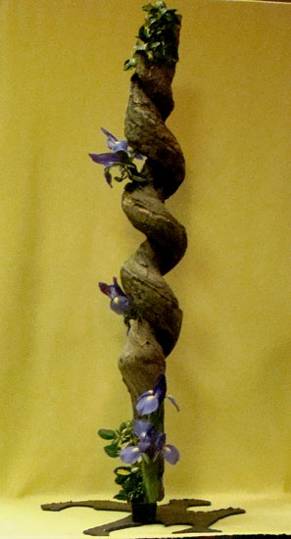
http://www.oagc.org/e%20&%20J%20schools/2013%20schools/creative-vertical.jpg
Myrna Cordray, Designer

Creative Horizontal Line-Mass
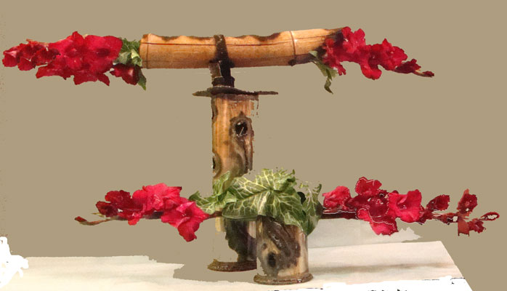
http://www.oagc.org/e%20&%20J%20schools/2013%20schools/creative-horizontal-line-ma.jpg
Elenor Long Designer

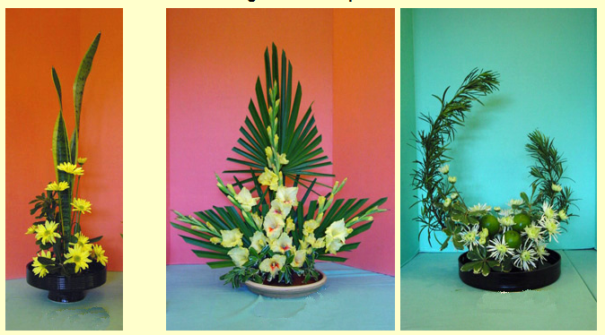

2007 New England Flower Show
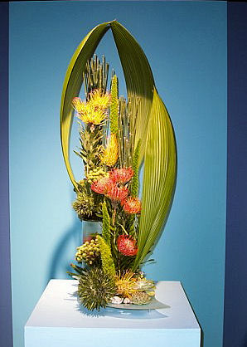
Maureen Christmas’s Creative Mass design for Class 103, Mysteries of the Deep, “I’m a scuba diver”, won the blue ribbon for the class and the Tricolor Award for the entry day. The design also won the Claire Richards Award, which may be given, if merited, in the Garden Club Federation of Massachusetts (GCFM) Design Division for the entry in a Tricolor Class that best exemplifies the sensitive use of color. The Claire Richards Award will be given once during the show and the winner need not be a blue ribbon winner.

Conejo Valley Garden Club: Creative Design Show CVGC Flower Show January 2011
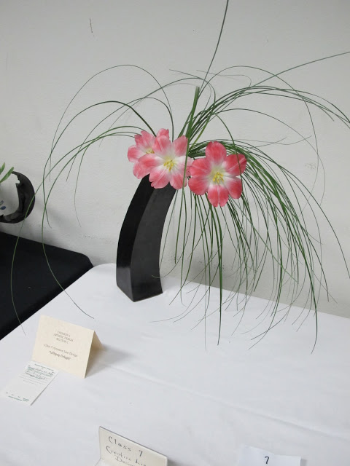
Class 7: Creative Line Design: 1st Place: Monica Lewis
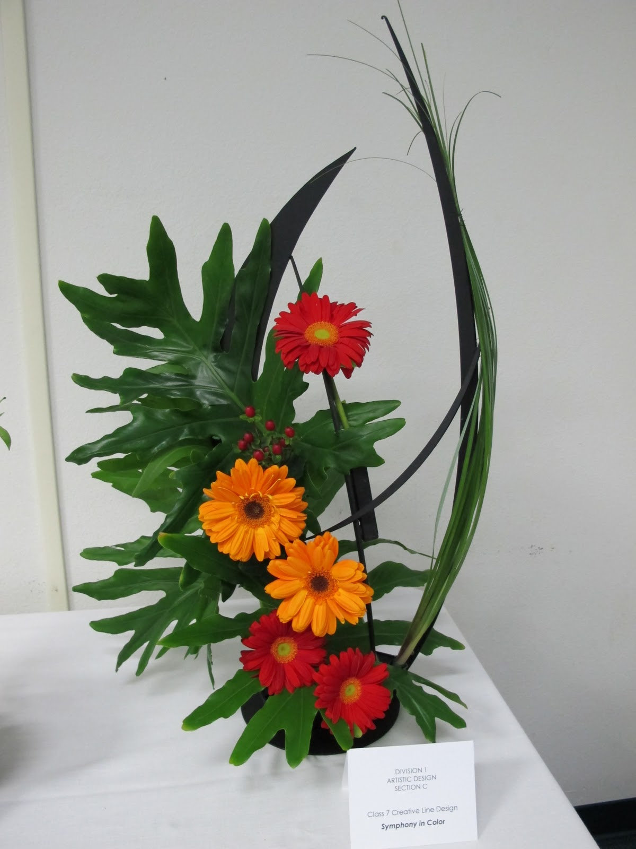

Class 7: Creative Line Design: 2nd Place: Gloria Aminian
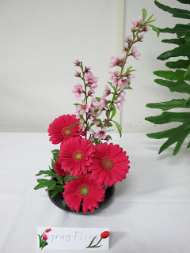Class 7: Creative Line Design: 3rd place: Pat Carlson
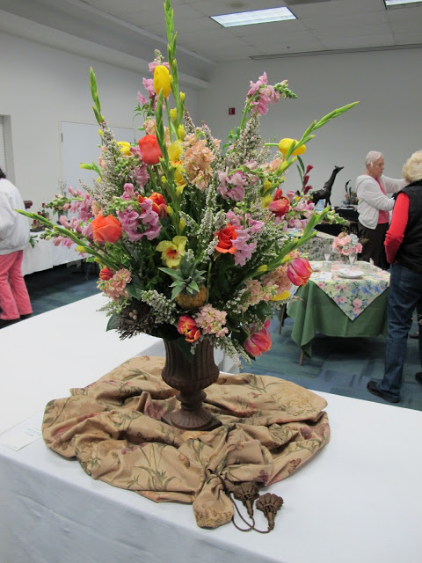
Class 3: Mass Design 1st Place Winner: Janet Switzer
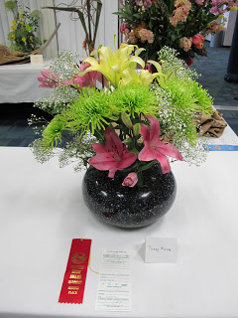 Class 3: Mass Design: 2nd Place: Lillian Trevisan
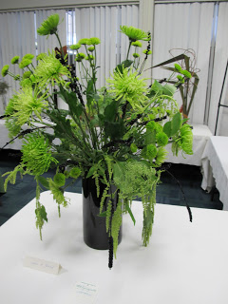Class 3: Mass Design: 3rd Place: Pat Zarnowski

Abstract Creative Vibratile
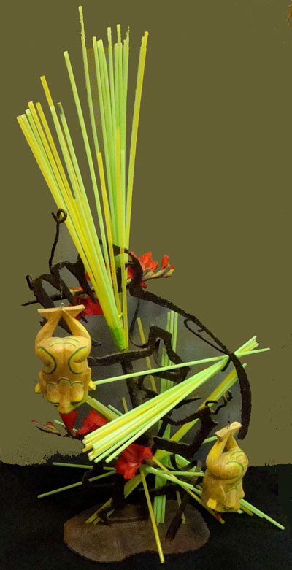
http://www.oagc.org/e%20&%20J%20schools/2013%20schools/DSC05423.jpg
Designer Myrna Cordray

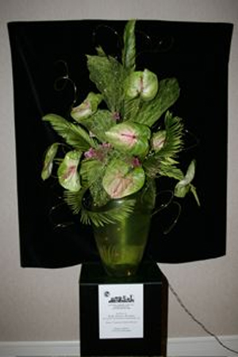

National Garden Clubs convention
Design in honor of Cathy Thomas President
Anthurium, skeletonized prickly pear, sago palm
http://gloriafreitas.com/gallery/index.php/Flower-Arrangements/4

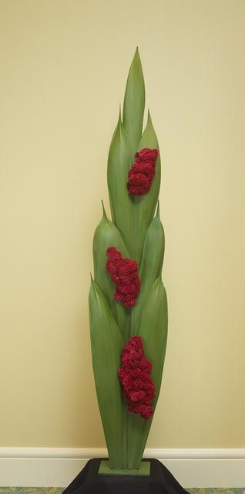

WAFA-USA Red Hat Society
a collection of Queen palm spathes, painted green and bunches of celosia
http://gloriafreitas.com/gallery/index.php/Flower-Arrangements/IMG_1169

Use of wood with Designs
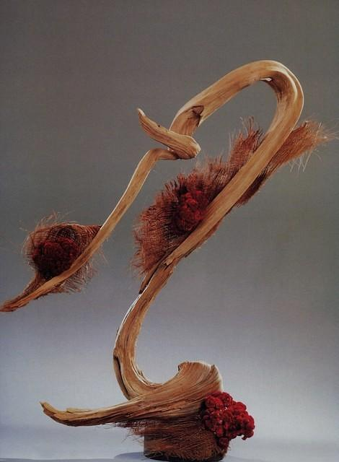

"Forward Motion"
Driftwood (cedar), Coconut sheeves, celosia.
http://gloriafreitas.com/gallery/index.php/Flower-Arrangements/Forward-Motion

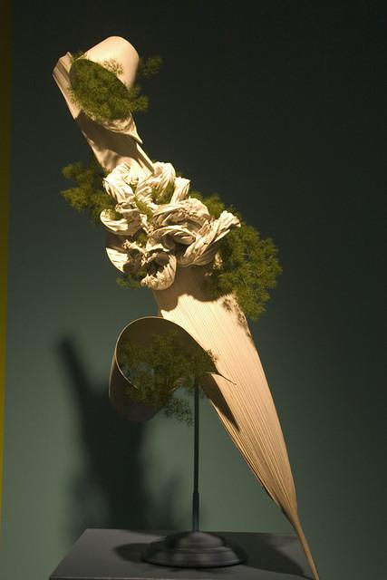

Boston FlowerShow "Ski Jump"
....palm spathe, ming fern painted white to represent snow. The ming fern represents a "spill" on the slope
http://gloriafreitas.com/gallery/index.php/Flower-Arrangements/07Mar_FlowerShow_030
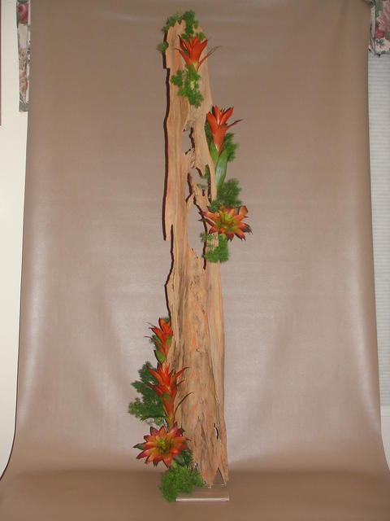

"Fire and Smoke" Tribute to Firefighters
Pecky cyprus wood, bromilias, ming fern....5' tall

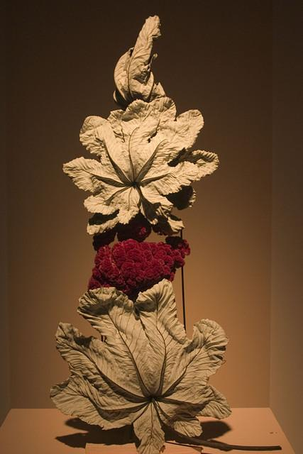

Mar FlowerShow "I am a Magician"
This motorized design (see next photo with it open) opens and closes. The mechanisn was taken out of a Halloween toy.
http://gloriafreitas.com/gallery/index.php/Flower-Arrangements/07Mar_FlowerShow_023
